





**AT**

**ON**



**CAN YOU MAKE IT? YES OR NO? EITHER WAY WE'D LIKE TO KNOW.**

**PLEASE R.S.V.P TO**



ADVERTISING_html_c76f52dd.png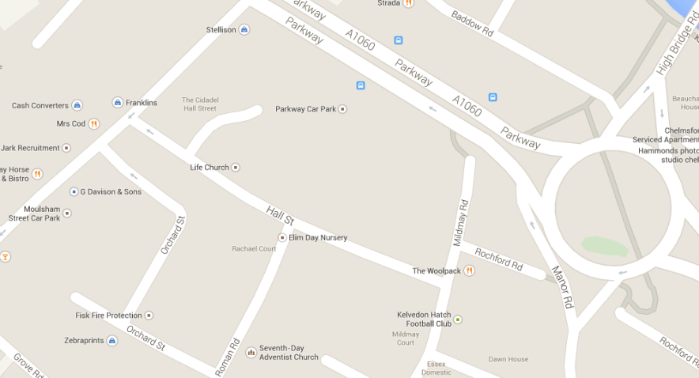

**KIDS & KOFFEE IS ALSO OPEN DURING THE WEEK! YOU CAN COME WITH YOUR LITTLE ONE(S) AND RELAX WHILST THEY BURN OFF SOME ENERGY IN OUR SAFE SOFT PLAY AREAS.**

**KIDS & KOFFEE IS ON HALL STREET, CHELMSFORD, CM2 0HG.**

**CALL 01245 259225**